**Authors : ALOWONOU Kowovi Comivi**

**Demba COUTA**

**Humidity and temperature control with arduino**

Table of Contents

**I.** **PROJECT DESCRIPTION** 2

**II.** **Hardware** 2

1. Piezo buzzer : 2

2. AM2321 Temperature and humidity sensor: 2

4. Connexion: 4

**III.** **Software** 5

5. C#/ ASP.NET for the web application, 5

6. Mysql Server as database. 5

7. IoT ThingSpeak. 6

**IV.** **Functionalities** 6

# **PROJECT DESCRIPTION**

The project's goal is to protect objects such as archeological objects, contained in a room, keeping them within a range of temperature and humidity to prevent their degradation.  
For this, a data acquisition system will be established (temperature and humidity sensor) to detect the humidity and the temperature of the room.  
If the temperature or humidity of the room reaches a certain maximum or minimum threshold then an alarm is triggered and a message is sent to the room manager. It will also be possible to follow the evolution of the temperature and humidity of the room through a web application.

# **Hardware**

## Piezo buzzer :

We will use for this project, a piezoelectric audio signaling device: Piezo buzzer.

It will make different sound depending on the value of the temperature and the humidity.

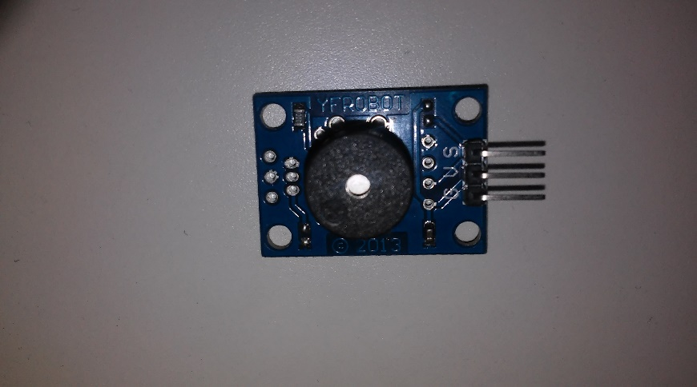

## AM2321 Temperature and humidity sensor:

AM2321 capacitive humidity sensing digital temperature and humidity sensor is a temperature and humidity own calibration digital signal output composite sensor. The sensor includes a capacitive sensor wet components and a high-precision integrated temperature measurement devices, and connected with a high-performance microprocessor.

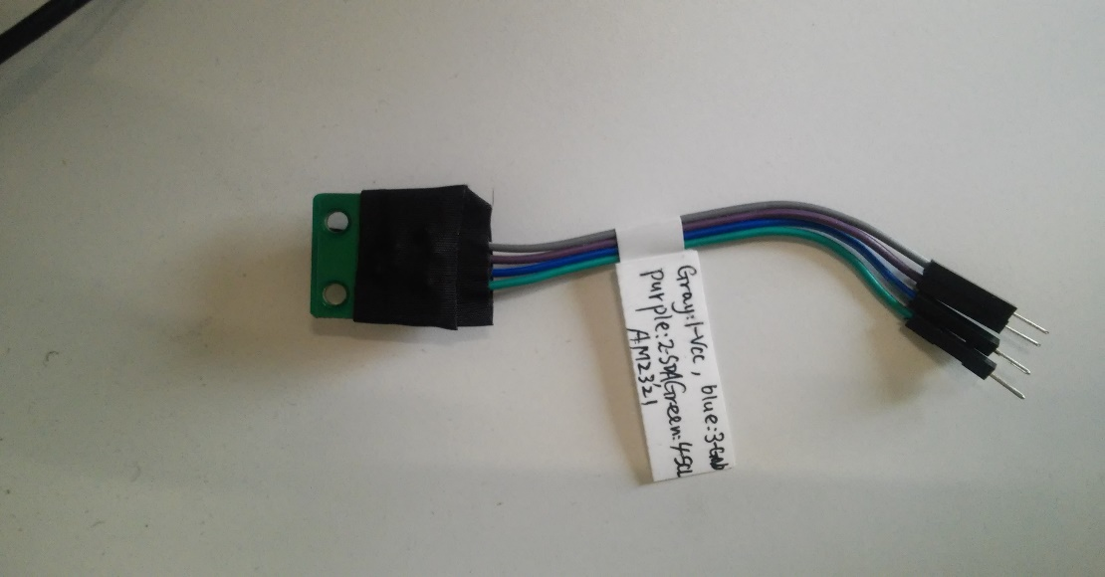

1. [Intel Galileo - Arduino](https://www.google.ae/url?sa=t&rct=j&q=&esrc=s&source=web&cd=1&cad=rja&uact=8&ved=0ahUKEwjeuL_c6ePPAhUoBMAKHbthCHoQFggcMAA&url=https%3A%2F%2Fwww.arduino.cc%2Fen%2FArduinoCertified%2FIntelGalileo&usg=AFQjCNGzBTBYMcoENWlQcsq_MhyNtdHhhA)

**Intel Galileo** is the first in a line of [Arduino](https://en.wikipedia.org/wiki/Arduino)-certified development boards based on [Intel](https://en.wikipedia.org/wiki/Intel) x86 architecture and is designed for the maker and education communities.

Intel Galileo combines Intel technology with support for Arduino ready-made hardware expansion cards (called "shields") and the Arduino software development environment and libraries. The development board runs an open source Linux operating system with the Arduino software libraries, enabling re-use of existing software, called "sketches". Intel Galileo can be programmed through OS X, Microsoft Windows and Linux host operating software. The board is also designed to be hardware and software compatible with the Arduino shield ecosystem.

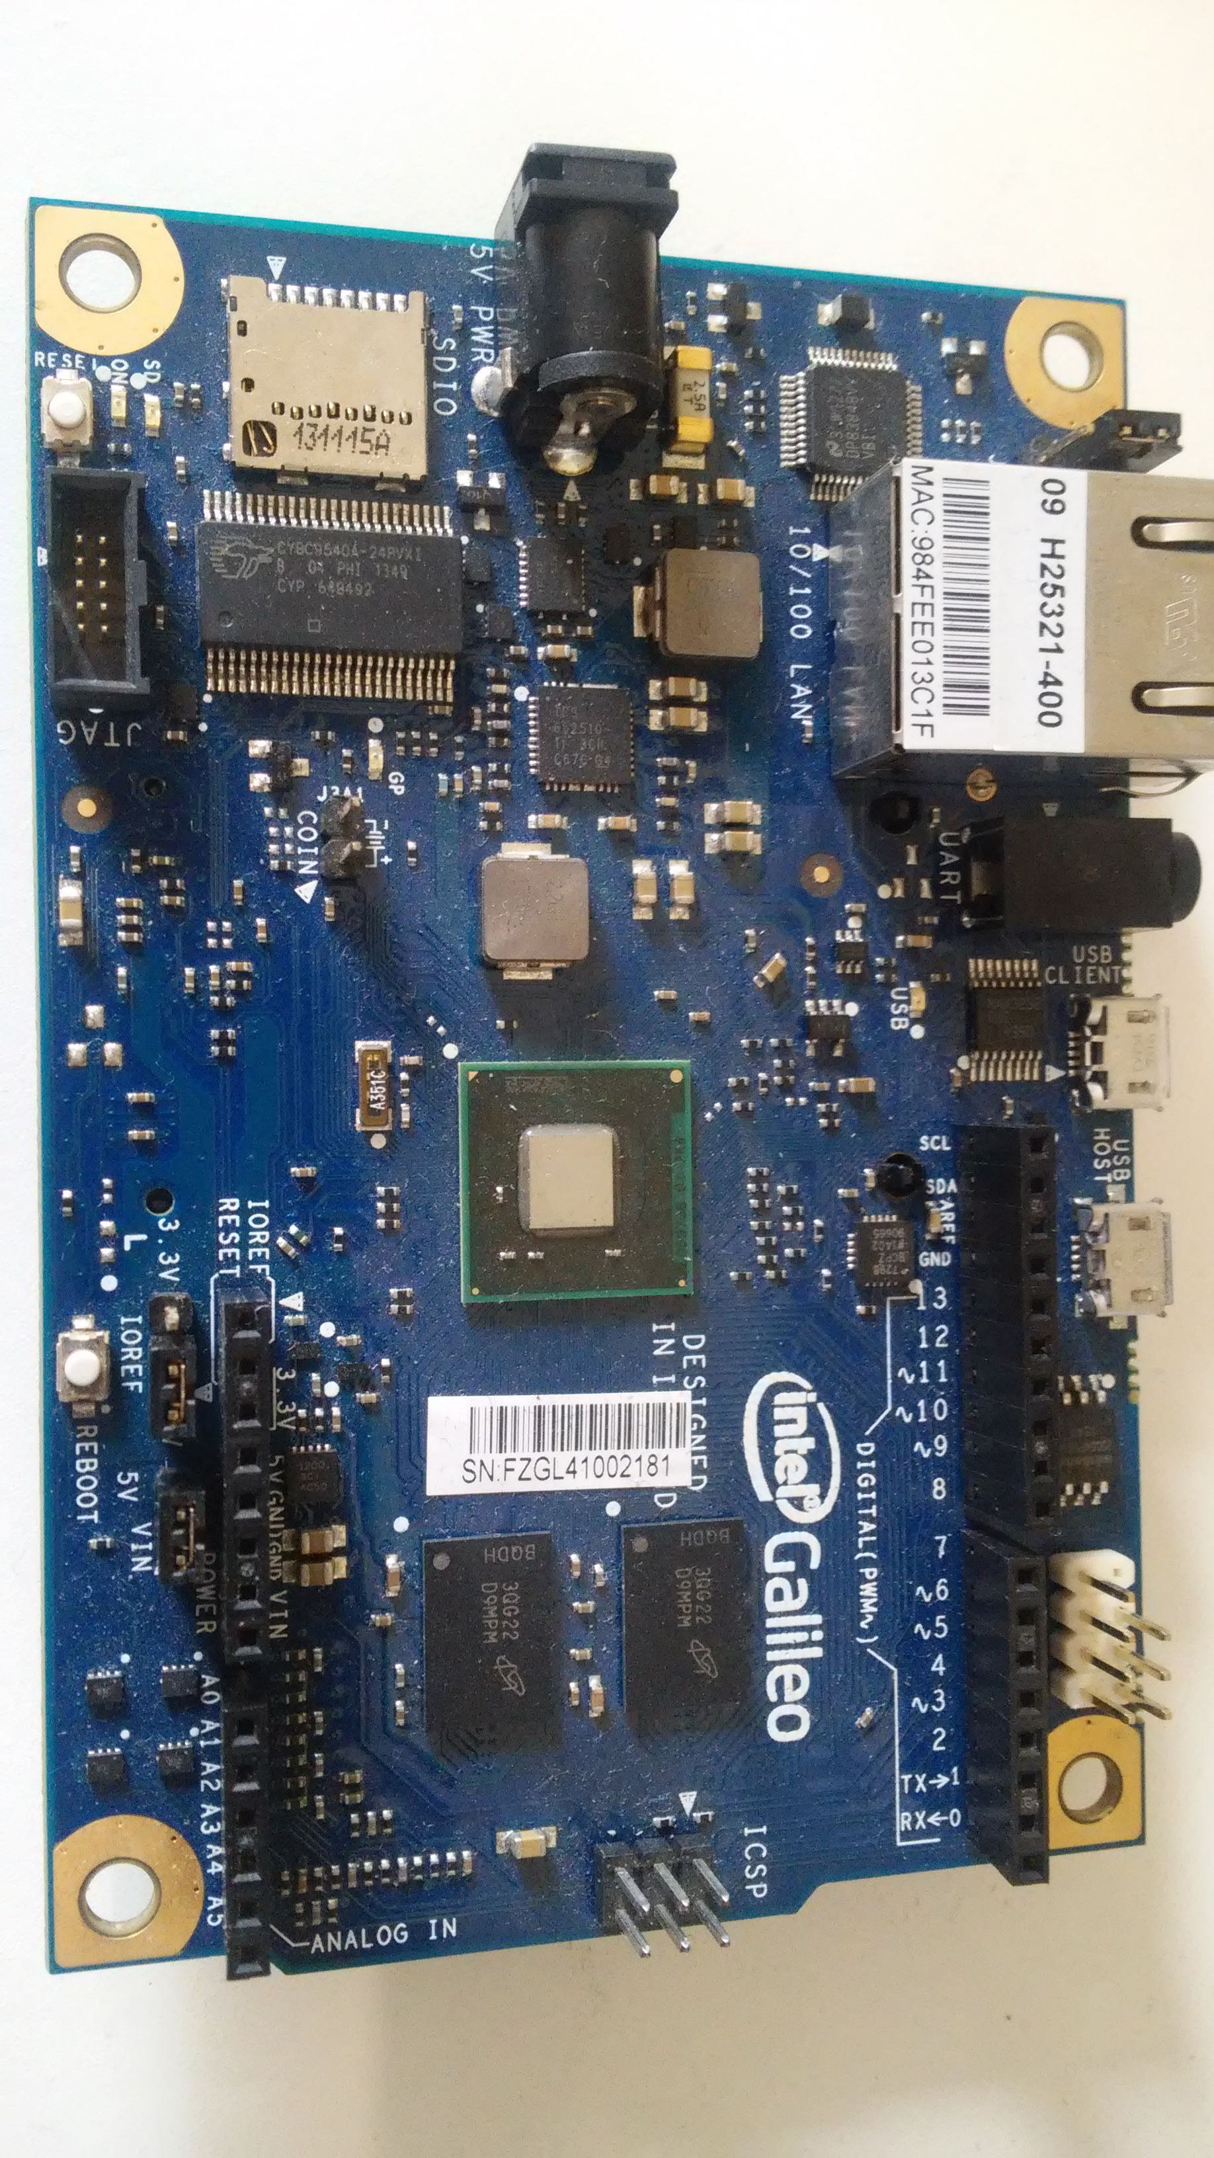

## Connexion:

AM2321 Connexion:

Gray -> VCC

Blue -> GND

Purple -> SDA

Green -> SCL

Piezo Buzzer:

GND

9v

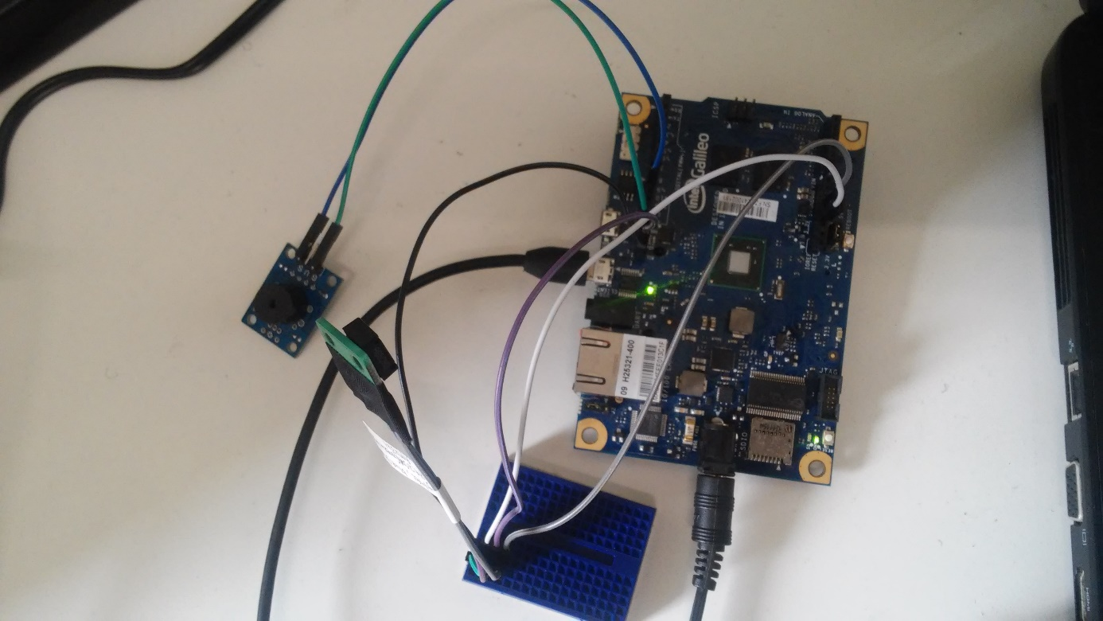

# **Software**

* + detect the humidity and the temperature of the room
  + an alarm is triggered

## C#/ ASP.NET for the web application,

* + C#/ ASP.NET for the web application,
  + Create the web App.
  + A message is sent to the room manager
  + possibility to follow the evolution of the temperature and humidity through a web application
  + settings

## Mysql Server as database.

DataBase name: arduinoproject

|  |  |  |
| --- | --- | --- |
| Table Param | | |
| ID | Identification | |
| tmax | The maximal temperature value | |
| tmin | The minimal temperature value | |
| hmax | The maximal humidity value | |
| hmin | | The minimum humidity value |
| StopAlarm | Turn to 1 if the alarm is switched off and 0 if not | |
| Alarm duration | Contain the duration on which alarm will be switched off. | |
| Mail | Contain the mail of the room’s manager | |

|  |  |
| --- | --- |
| Table temphumd | |
| ID | Identification |
| temp | temperature value |
| humd | humidity value |
| Date | Date of date saving |

|  |  |
| --- | --- |
| Table user | |
| ID | Identification |
| Name | Name of the user |
| password | User password |

## IoT ThingSpeak.

* + Permit to send the data(temperature and humidity’s values ) to the phone
  + Phone rings
  + Draw the graph of the Humidity and the temperature over the time

# **Functionalities**

This project consist on web application and mobile application, to control the evolution of the temperature and the humidity, and trigger an alarm when they have reached a specified threshold.

When the temperature and humidity have reached a specified threshold then:

* An alarm is trigged.

There are different kind of sound: Sound for temperature and sound for humidity.

* An mail is sending to the room’s manager to show him the temperature and the humidity values
* And his phone is ringing to warn him of the temperature or the humidity level.

The room’s manager can set up the minimum and maximum values of temperature and humidity that should not be exceeded.

In case the alarm is trigged, he can stop it fix the problem by increasing or decreasing the temperature or the humidity.

If he stop the Alarm and doesn’t fix the problem, the alarm will be trigged again after 30min.